PHYS1110D – Engineering Physics: Mechanics and Thermodynamics

Week 5: Common Confusion in Assignment 2

**Problem 3**

A 60 kg block (block 2), on top of a table, is attached to a pulley (short thick red rope in the figure). A long black rope is attached to one end of the table, goes through this pulley, then through a second pulley and its other end is attached to a 5 kg block (block 1) that hangs vertically, as shown below. No friction is involved, and the pulleys have **negligible masses**. Notice that when block 1 descends a distance , the horizontal displacement of block 2 is .

1. Draw a free-body diagram for the pulley on the left;
2. Find the acceleration of block 1.

**Solution:**

1. We are pleased to see that some of you tried using the energy arguments to solve this question (maybe you listened carefully on the Tutorial Session of Week 4). But unfortunately, *all* of these students failed in getting the right answer: they never think seriously *whose* energy they are dealing with. Now we give the correct solution.

We treat the two blocks, the pulleys and the rope as a whole system. It is easy to see that the only force that does work on this system is the gravity of block 1. When drops a distance of , this work is

The work is converted to the kinetic energy of *both* block 1 and block 2 (*some confused students will forget one of the two blocks*). *By definition*, the velocities of the two blocks are given by

(*Some naïve students write*

*However, this simple relation holds for* ***constant-velocity*** *motion only, and you should never apply it to any situation without thinking with your* ***brain****.*)

Now the change in kinetic energy is

Then we take the time derivative of both sides:

Since

We obtain

**Problem 4**

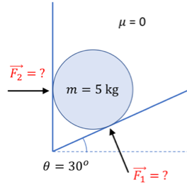A solid ball is placed in a wedge formed by two planes as shown in the figure. Assuming no friction between the ball and the walls:

1. What are the directions of the forces exerted by the walls?
2. Find the magnitude of both forces
3. If, instead of , we make , what are the magnitudes of the forces on the ball?

**Solution:**

1. We are heartbroken when we found that many of you wrote down the relation

Didn’t you *feel* that something unreasonable would happen if the relation was true? That’s why the teacher designed question 3. You should see the absurdity after doing it, but those students just hurried over the last question and never reflected on what they have done. *Homework assignments are different from a closed-book exam: you should try to think as much as possible about the questions. After taking the exam, you just throw the questions away, but you should never do the same thing to assignment problems.*